Ladies Only - South Africa Surprise
Johannesburg - Lowveld - Swaziland - KwaZulu Natal North Coast - Durban - Southern Drakensberg - Eastern Cape Beaches - Port Elizabeth - Knysna - Mossel Bay - Cape Town
17 Days / 16 Nights
22 July 2017 - 07 August 2017

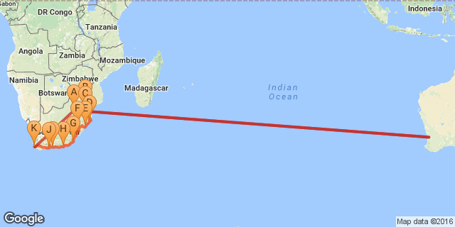

Click here to view your Digital Itinerary

Overview

THE AFRICA SAFARI CO. - LADIES ONLY - SOUTH AFRICA SURPRISE
15 days Fully Guided Iconic Highlights Journey- Fundamentals
Johannesburg | Hazyview | Kruger National Park | Swaziland | Zululand | Durban | Drakensberg | Eastern Cape | Port Elizabeth |Knysna | Mossel Bay | Cape Town
Get a group of friends together and enjoy 15 days of fun, freedom and fascination on this Ladies Only tour – Have a ball as you discover the “World in one Country” South Africa.
A vast land of unimaginable beauty and diversity of experiences, is set to take your breath away. This incredible tour, taking in the very best of South Africa will surprise you with its variety, fun and adventure.

Accommodation | Destination | Arr. | Dep. | Nights | Basis
Overnight Travel |  | 22 Jul | 23 Jul | 1
Protea Hotel OR Tambo International | Johannesburg | 23 Jul | 24 Jul | 1 | B&B
Hippo Hollow Country Estate | Lowveld | 24 Jul | 26 Jul | 2 | B&B
Lugogo Sun | Swaziland | 26 Jul | 27 Jul | 1 | B&B
Protea Hotel Umfolozi River | KwaZulu Natal North Coast | 27 Jul | 28 Jul | 1 | B&B
Protea Hotel Umhlanga Ridge | Durban | 28 Jul | 29 Jul | 1 | B&B
Drakensberg Gardens Golf & Spa Resort | Southern Drakensberg | 29 Jul | 31 Jul | 2 | D, B&B
Crawford's Beach Lodge | Eastern Cape Beaches | 31 Jul | 1 Aug | 1 | D, B&B
Garden Court King's Beach | Port Elizabeth | 1 Aug | 2 Aug | 1 | B&B
Knysna Hollow Country Estate | Knysna | 2 Aug | 3 Aug | 1 | D, B&B
Garden Court Mossel Bay | Mossel Bay | 3 Aug | 4 Aug | 1 | B&B
SunSquare Cape Town | Cape Town | 4 Aug | 6 Aug | 2 | B&B
Overnight Travel |  | 6 Aug | 7 Aug | 1

Key
RO: Room only. B&B: Bed and breakfast. D, B&B: Dinner, bed and breakfast. FB: Dinner, bed, breakfast and lunch. FB+: Dinner, bed, breakfast, lunch and activities daily. FI: Fully inclusive.

Included
- Return economy class airfares from Sydney to Johannesburg/Cape Town
- Applicable taxes
- Transportation in luxury coach
- 3-star accommodation
- Breakfast daily
- 4 dinners
- All touring & sightseeing as per itinerary
- Porterage & VAT.
(Please note that conservation levies are subject to increase without prior notice and is at the discretion of the game park.)

Excluded
- Optional Touring Activities
- Meals and beverages where unspecified
- Gratuities
- Items of a personal nature
- Travel insurance

Transport

Flight Information
Date | Departure Airport | Arrival Airport
22 Jul | Sydney International Airport [SYD] | Perth International Airport [PER]
23 Jul | Perth International Airport [PER] | OR Tambo International Airport [JNB]
06 Aug | Cape Town International Airport [CPT] | OR Tambo International Airport [JNB]
06 Aug | OR Tambo International Airport [JNB] | Perth International Airport [PER]
07 Aug | Perth International Airport [PER] | Sydney International Airport [SYD]

Road Transfers
Date | Pick Up | Drop Off
23 Jul | OR Tambo International Airport [JNB] | Protea Hotel OR Tambo International
24 Jul | Protea Hotel OR Tambo International | Lydenburg
24 Jul | Lydenburg | Blyde River Canyon
24 Jul | Blyde River Canyon | Hippo Hollow Country Estate
26 Jul | Hippo Hollow Country Estate | Jeppe's Reef Border Post
26 Jul | Jeppe's Reef Border Post | Lugogo Sun
27 Jul | Lugogo Sun | Hluhluwe Imfolozi Game Reserve
27 Jul | Hluhluwe Imfolozi Game Reserve | Protea Hotel Umfolozi River
28 Jul | Protea Hotel Umfolozi River | St Lucia
28 Jul | St Lucia | Protea Hotel Umhlanga Ridge
29 Jul | Protea Hotel Umhlanga Ridge | Howick
29 Jul | Howick | Drakensberg Gardens Golf & Spa Resort
31 Jul | Drakensberg Gardens Golf & Spa Resort | Mthatha
31 Jul | Mthatha | Qunu
31 Jul | Qunu | Crawford's Beach Lodge
01 Aug | Crawford's Beach Lodge | Port Alfred
01 Aug | Port Alfred | Garden Court King's Beach
02 Aug | Garden Court King's Beach | Tsitsikamma National Park
02 Aug | Tsitsikamma National Park | Knysna Hollow Country Estate
03 Aug | Knysna Hollow Country Estate | Oudtshoorn Town
03 Aug | Oudtshoorn Town | Robertson Pass
03 Aug | Robertson Pass | Garden Court Mossel Bay
04 Aug | Garden Court Mossel Bay | Albertinia
04 Aug | Albertinia | Robertson
04 Aug | Robertson | SunSquare Cape Town
06 Aug | SunSquare Cape Town | Cape Town International Airport [CPT]

Day 1: Overnight Travel (Sat, 22 July)

Day Itinerary
Depart Sydney and fly to Perth for your connecting overnight flight to Johannesburg.

Day 2: Protea Hotel OR Tambo International, Johannesburg (Sun, 23 July)

Day Itinerary
On arrival in Johannesburg you will be met and assisted to your shuttle transfer service to the hotel. You have the remainder of the day at leisure until 19h00 when we all meet at the hotel reception for a briefing on the tour and a chance to meet up with your fellow travellers.
Accommodation: Protea Hotel OR Tambo or similar

Johannesburg
Johannesburg is one of Africa’s biggest and most vibrant cities. It is the economic capital of Africa and the gateway to Southern Africa. Although not as famous as other South African destinations, there is plenty to do in Johannesburg and nearby Pretoria. The old city is a multi-cultural mixture of traditional medicine shops, Chinese restaurants, taxi ranks and ultra-modern skyscrapers. There are excellent museums, art galleries and organised tours of historical and political interest. The shopping is Southern Africa’s best and the many restaurants cater for all tastes. The nearby township of Soweto is Johannesburg’s most popular tourist attraction.

Overnight: Protea Hotel OR Tambo International
Time-conscious local and international business travelers will enjoy this convenient hotel located 35 minutes from Sandton and Pretoria, and situated just 800m from the Rhodesfield Gautrain Station. Whether stopping over or have an extended business stay ahead, Protea Hotel O.R. Tambo Airport has everything travelers need. Here, no detail has been spared to ensure that business travelers can conduct their day-to-day business efficiently and comfortable, with each room provides a direct dial telephone, large executive work desk and a laptop safe. There’s also the vibrant á la carte restaurant, relaxing bar with free Wi-Fi, swimming pool and health club. If you’re conducting business, ask about our state-of-the-art conference facilities.
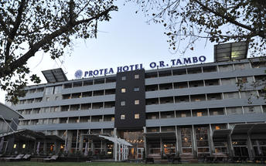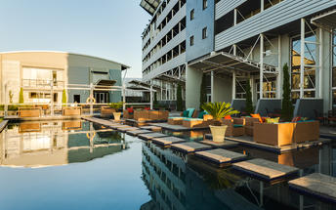

Optional Tour NOT included: Soweto Day Tour
A Soweto Day Tours takes in the highlights of this iconic township including Nelson Mandela’s former home and the Hector Pieterson museum (he was one of the school children who was shot in the 1976 Soweto Uprising). You will get close to Soweto Culture, meeting the people, trying local foods and maybe even some Omqombothi (our traditional beer) at a shebeen. This tour is one of a kind, the smell of pavement cooked meals and the buzz in the streets of people going about their daily chores. Come and experience township life, the humanity, hospitality and warmth of the people, the "Ubuntu" as it is known in South Africa.

Included
Bed & Breakfast

Day 3: Hippo Hollow Country Estate, Lowveld (Mon, 24 July)

Day Itinerary
This morning we leave for Mpumalanga, dropping several hundred feet into the lush subtropical region of the Lowveld. Travel along the circular Panorama Route via Graskop, visiting the view sites of the Blyde River Canyon, one of the natural wonders of Africa; gasp at the glory of God’s Window, with a boundless view of mountains and fertile plains and finally a visit to Bourke’s Luck Potholes before heading to Hazyview.
Accommodation: Hippo Hollow Country Estate

Panorama Route
The Panorama Route is one of the most beautiful parts of South Africa connecting the Lowveld and the amazing geological features of the Mpumalanga Drakensberg. One of the major highlights of the region is the Blyde River Canyon Reserve, the third largest canyon of its kind in the world and home to spectacular wildlife and birdlife. Other highlights include the breathtaking waterfalls in Graskop and Sabie, Lisbon and Berlin Falls, Gods Window and the Gold Rush territory, Pilgrim’s Rest, home to the early gold prospectors.

Blyde River Canyon
The third largest canyon in the world, the Blyde River Canyon is exceptional for being the largest forested canyon in the world. The views from the rim are spectacular, especially the renowned view that includes the Three Rondavels. There are mountain reedbucks on the escarpment, dassies on the canyon walls, hippo and crocodile in the Blyde Dam and a rich selection of birdlife throughout, including a breeding colony of the rare bald ibis.

Bourke's Luck Potholes
The Treur River plunging into the Blyde River has caused waterborne sand and rock to create huge potholes, some six metres deep, into the bedrock of the river. This natural water feature is known as Bourke’s Luck. There is a well-developed picnic area here and a series of walkways and bridges that enable visitors to get great views of this amazing geological feature. Another attraction at Bourke's Luck is the visitors' centre, which has numerous interesting displays. A newly developed, 180 m circular trail, accessible to the physically disabled, starts at the visitors' centre and has as its main theme the lichens found in the area.

God's Window
God’s Window looks out over the Drakensberg escarpment dropping 1000m below, offering a view of the lowveld stretching out towards the Kruger National Park. Magnificent montane forest, canyons, rock formations and waterfalls can all be seen.

Lowveld
The Mpumalanga Lowveld lies between the northernmost reaches of the Drakensberg Escarpment and the Kruger National Park. It is renowned for its sub-tropical climate, excellent farming areas and great access to the game reserves and attractions of the Panorama Route.

Overnight: Hippo Hollow Country Estate
Hippo Hollow Country Estate is situated outside Hazyview on the Sabie River between the Drakensberg Mountains to the west and the low-lying bushveld to the west. It is the ideal destination from which to access the reserves of the Lowveld and the sights of Mpumalanga. Hippo Hollows is only ten minutes from the Kruger National Park and the panoramic route which includes Pilgrim's Rest, Graskop, Bourkes Luck Potholes, God's Window, the Blyde River Canyon, and the many fantastic waterfalls of the escarpment is close by. Hippo Hollow Country Estate provides the ideal breakaway from the rigorous of city life. The hotel has an 'Out of Africa ' feel about it, and leaves you feeling totally relaxed and refreshed.
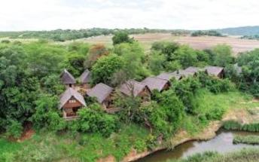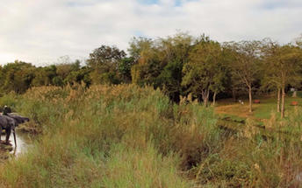

Included
Bed & Breakfast

Day 4: Hippo Hollow Country Estate, Lowveld (Tue, 25 July)

Day Itinerary
We have a bright and early start to the day in order to experience the wonders of exploring the Kruger National Park in our closed vehicle. Spend a morning with the Big Five in the Kruger National Park. The Kruger National Park is an internationally renowned game reserve of nearly 2 million hectares and supports the largest variety of wildlife species on the African continent. Keep a lookout for the wonderful flora and bird life that abounds. We return to our hotel around lunch time and your afternoon is at leisure.
Accommodation: Hippo Hollow Country Estate

Kruger National Park
At more than 2 million hectares the Kruger National Park is one of the world’s largest game reserves and a truly remarkable destination. Because of its exceptional size you can experience amazing diversity – from the scenery and ecosystems to the correspondingly amazing array of animals, trees and birds. A trip to the Kruger National Park is an unforgettable and potentially life changing experience.

Optional Tour NOT included: Shangaan River Club
Immerse yourself in a Feast of Culture, with a night of Shangaan song and dance, and an unforgettable African Banquet at the Shangaan River Club based at Hippo Hollow Hotel in Hazyview.

Optional Tour NOT included: Elephant Whispers
WE INVITE YOU TO EXPERIENCE...The thrill of close encounters with the Majestic African Elephant.
Witness their intelligence, compassionate nature and the sheer delight the elephant experience when interacting with their human counterparts. The Elephant Interaction offers you the opportunity to feel their constantly curious trunks, touch their rough skin, exchange trunk greetings and offer tasty treats, while learning about their behaviour and history from the Elephant Handlers. An Elephant Back Ride offers a different perspective; embark on a journey which was once a privilege reserved only for kings!
For those seeking a unique and memorable wildlife encounter, an Elephant Interaction and Ride at Elephant Whispers is an exciting and touching experience not to be missed. Situated in the Sandford Conservancy on the banks of the Sabie River in Hazyview, Mpumalanga, Elephant Whispers offers an Elephant Experience of a lifetime which will leave you with a renewed respect and admiration for these gentle giants of Africa.

Included
Bed & Breakfast

Day 5: Lugogo Sun, Swaziland (Wed, 26 July)

Day Itinerary
This morning after breakfast, we check out and depart on our journey to Swaziland. We proceed south to Malalane and then onto Swaziland where this afternoon you will visit a real Chief’s village and have the fantastic opportunity to gain an authentic knowledge of traditional Swazi culture
Accommodation: Lugogo Sun

Swaziland
This tiny, land-locked nation boasts a rich historical and cultural heritage. Swaziland encompasses a diverse array of ecosystems – towering mountains and low-lying savannah, tangled rainforests and lush river valleys. Highlights of this laid-back land include the mesmerizingly beautiful ‘Valley of Heaven’, the handicraft haven of the Malkerns Valley and the Hlane Royal National Park, famed for its white rhinos, antelopes and lions.

Overnight: Lugogo Sun
The Lugogo Sun hotel is one of the fine Swaziland hotels that make up the Royal Swazi Spa Valley resort . The hotel’s location takes full advantage of the tranquillity of the surrounding Ezulwini Valley, allowing guests to feel completely relaxed upon driving onto the grounds. Surrounded by nature, mountains and a host of activities and facilities make for a memorable holiday. The hotel overlooks a sub-tropical garden and 72-par golf course landscape and numerous in-house activities, as well as external things to do you’ll never be short of things to do.
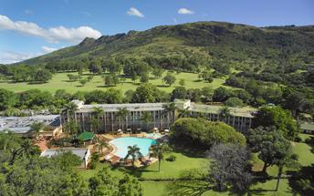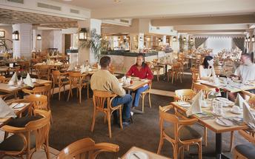

Swaziland
This tiny, land-locked nation boasts a rich historical and cultural heritage. Swaziland encompasses a diverse array of ecosystems – towering mountains and low-lying savannah, tangled rainforests and lush river valleys. Highlights of this laid-back land include the mesmerizingly beautiful ‘Valley of Heaven’, the handicraft haven of the Malkerns Valley and the Hlane Royal National Park, famed for its white rhinos, antelopes and lions.

Included
Bed & Breakfast

Day 6: Protea Hotel Umfolozi River, KwaZulu Natal North Coast (Thu, 27 July)

Day Itinerary
This morning we journey through Swaziland into Zululand. Our journey continues into the Kingdom of KwaZulu-Natal where ancient traditions and modern cultures of both Zulu and Settler have combined into a vibrant society living in peace and harmony. Arrive this afternoon in the Umfolozi area for your overnight stay.
Accommodation: Protea Hotel Umfolozi

KwaZulu Natal North Coast
The KwaZulu Natal North Coast offers spectacular beaches all along its coastline and is divided into two distinct sections. Just north of Durban are the well developed beach resorts and golf courses, while the far north provides miles and miles of unspoilt beaches, wetlands and lake systems. So whether you’re after a 5-star hotel overlooking a beach, or camping in the dunes and diving with dolphins, the KwaZulu Natal coastline has it all and more.

Overnight: Protea Hotel Umfolozi River
This hotel is ideally located in the Greater Hluhluwe/Umfolozi Game Reserve area, just 40km north of Richards Bay. Activities near Protea Hotel Umfolozi River include the Greater St. Lucia Wetlands Park, Hluhluwe/Umfolozi Game Reserve, world-renowned birding spots, whale and dolphin watching, boat cruises, horse riding, golf, fishing, kayaking, beaches and quad bike trails. It’s a hotel that complements your travel style. Dining facilities at the hotel include a restaurant and bar, with conference facilities available for up to 400 delegates seated in school-room style, while banqueting facilities for weddings, launches or cocktail parties are available for up to 240 guests.
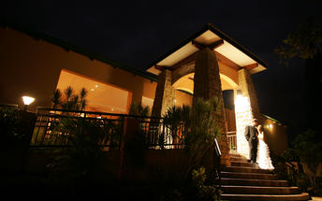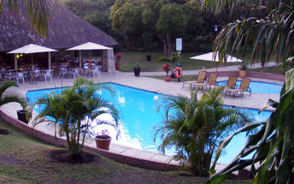

Zululand
The well watered valleys have been home to the Zulus, their cattle and wildlife for centuries and today Zululand is a fascinating mix of tribal lands, game reserves and commercial agriculture.

Optional Tour NOT included: Hluhluwe Imfolozi Game Reserve
The Hluhluwe-Umfolozi Game Reserve is the jewel in the crown of the KwaZulu Natal game reserves. Proclaimed in 1895, it is also the oldest game reserve in Africa. Initially two separate reserves, they were joined to create a single 94 000 hectare reserve which is home to one fifth of the world's black and white rhino population. It was here that the internationally acclaimed Operation Rhino started in the 1960s, successfully capturing and relocating white rhino to havens within South Africa and abroad. As a result, this country's white rhino population is now 12 times the 1960 count of 500. Today Hluhluwe-Umfolozi is focusing its efforts on saving the endangered black rhino, whose number in Africa dwindled from 14 000 to a pitiful 2 550 in the 1990s. The Hluhluwe-Umfolozi Game Reserve was the first reserve to introduce walking safaris and its Wilderness Trails are internationally renowned.

Included
Bed & Breakfast

Day 7: Protea Hotel Umhlanga Ridge, Durban (Fri, 28 July)

Day Itinerary
Guests have the option to lie in or take an optional morning boat cruise (own account) or simply soak up the atmosphere of this tourist town St Lucia before heading off later in the morning towards Durban. An orientation tour introduces us to this multicultural, vibrant seaside city before arriving at our hotel late afternoon.
Accommodation: Protea Hotel Umhlanga Ridge

Durban
With its beautiful beaches, lively wining and dining scene, and rich cultural heritage, Durban is KwaZulu Natal’s tourist hub. The swimming and surfing is rated the best of any major city across the world and because of the sub-tropical climate the water is warm all year round. Known as the Golden Mile, this stretch of beaches and amusement parks is Durban’s major attraction with the recently developed UShaka Marine World at the southern end providing a world class aquarium and other entertainments.

Overnight: Protea Hotel Umhlanga Ridge
Explore some of the many attractions located along the KwaZulu Natal Coastline and discover an area rich in Zulu heritage, game parks and beautiful beaches. Conveniently located opposite the Gateway Theatre of Shopping and just minutes from the uMhlanga Beach and King Shaka International Airport, the Protea Hotel Umhlanga Ridge exudes urban tranquillity. Our leisure GUESTS have the freedom to indulge in a number of entertainment activities near the hotel, while business GUESTS can get everything done using our conferencing facilities. Equipped with modern furnishings and facilities, the hotel has an excellent restaurant that serves delicious meals in a relaxed atmosphere and a roof-level pool with stunning views over Gateway and uMhlanga. Each contemporary, Colonial-style room boasts laminated timber floors and a light, serene atmosphere perfectly suited to Durban’s climate. One look at the view will leave you wishing you could stay just one more day.
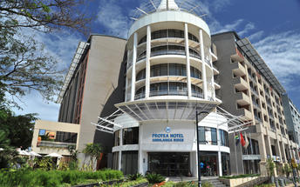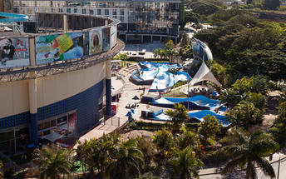

Optional Tour NOT included: St Lucia Boat Cruises
Witness and observe the hippos and crocodiles as well as hundreds of bird species on the Hippo & Croc Boat Cruise St Lucia. The 2 hour cruise allow passengers to get a close up of the estuary. On board the 15 seat vessel are knowledgeable and experienced skippers/rangers providing great insight and facts about the magnificent estuary system. Passengers may also hop off and walk along the banks and savanna grasslands to experience the wildlife with an experienced game ranger. Shaded decks protect you from the sun and snacks and drinks are on sale on board.

Included
Bed & Breakfast

Day 8: Drakensberg Gardens Golf & Spa Resort, Southern Drakensberg (Sat, 29 July)

Day Itinerary
This morning, enjoy a leisurely breakfast or perhaps take an early morning cab ride for a stroll along the Umhlanga Beach Promenade which buzzes with energy as surfers, joggers and cyclists take to this seaside playground. Then we head into the majestic Southern Drakensberg Mountains. We proceed on a visit to the 300 foot high Howick Falls, continuing through the Southern Midlands Meander Route, arriving at our hotel mid-afternoon. Your afternoon is at leisure to soak up the surroundings, or go fishing, hiking and even horse riding in clean mountain air (own account).
Accommodation: Drakensberg Gardens Resort Hotel & Spa or similar

Southern Drakensberg
The Southern Drakensburg is a wonderland of woodlands, forests, lakes and rivers, all set against the dramatic backdrop of this spectacular mountain range. Several nature reserves fall into the area and protect a wide variety of flora and fauna, including some rare antelope species and, at Kamberg, a network of beautiful hiking trails lead to caves decorated with ancient Khoisan art. Trout thrive in the region’s reservoirs and waterways, making it a magnet for fly-fishermen, while horse riding and mountain biking are also popular pursuits in this scenic part of the world. The ultimate highlight of the Southern Drakensburg, however, is the Sani Pass, which – at almost 3,000 metres above sea level – is South Africa’s highest pass, leading all the way to the Lesotho border and offering magnificent vistas along the way.

Overnight: Drakensberg Gardens Golf & Spa Resort
In the foothills of the scenic southern Drakensberg, which forms part of the uKhahlamba World Heritage site, is the Drakensberg Gardens Hotel. This is Nature in all its glory - grandiose scenery composed of the Drakensberg mountain chain, rivers and lakes. The mountains form an immense amphitheatre dominated by the highest peak - Mont-aux-Sources (3248m). Wonderful diversity of flora and fauna await discovery. The resort is conveniently located on an 860-acre estate bordering KwaZulu Natal Wildlife land, allowing access to spectacular walks and hikes - the most strenuous being a 9 hour hike up the Rhino Horn 9842.4 ft (3000 metres) above sea level.
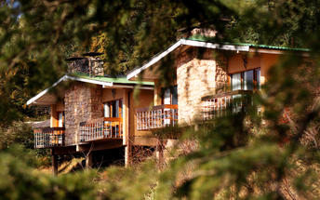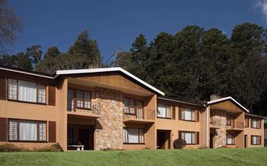

Included
Dinner, Bed and Breakfast

Day 9: Drakensberg Gardens Golf & Spa Resort, Southern Drakensberg (Sun, 30 July)

Day Itinerary
Full day at leisure to soak up the surroundings of the magnificent Southern Drakensberg Mountains. Today a host of leisure activities awaits you against a breath taking back drop of tranquil beauty.
Accommodation: Drakensberg Gardens Resort Hotel & Spa or similar

Southern Drakensberg
The Southern Drakensburg is a wonderland of woodlands, forests, lakes and rivers, all set against the dramatic backdrop of this spectacular mountain range. Several nature reserves fall into the area and protect a wide variety of flora and fauna, including some rare antelope species and, at Kamberg, a network of beautiful hiking trails lead to caves decorated with ancient Khoisan art.
Trout thrive in the region’s reservoirs and waterways, making it a magnet for fly-fishermen, while horse riding and mountain biking are also popular pursuits in this scenic part of the world. The ultimate highlight of the Southern Drakensburg, however, is the Sani Pass, which – at almost 3,000 metres above sea level – is South Africa’s highest pass, leading all the way to the Lesotho border and offering magnificent vistas along the way.

Optional Tour NOT included: Sani Pass
The only driveable pass over the Ukhahlamba-Drakensberg Mountains.

Included
Dinner, Bed and Breakfast

Day 10: Crawford's Beach Lodge, Eastern Cape Beaches (Mon, 31 July)

Day Itinerary
This morning we continue south to the Eastern Cape entering the fourth of the provinces and the birth place of Nelson Mandela (fondly known as Madiba). En route we see the old traditional way of life in the homeland area known as the Transkei and stop for lunch outside the capital of Mthatha. We continue via Nelson Mandela’s birth place and house, arriving late afternoon at our accommodation in Chinsta East, on the beautiful, unspoilt Eastern Cape Coast.
Accommodation: Crawford’s Beach Lodge

Eastern Cape Beaches
The Eastern Cape is endowed with some of the best beaches in South Africa – long stretches of fine white sand backed by hills blanketed with lush subtropical vegetation and, for the most part, blissfully uncrowded. The Indian Ocean waters that fringe this coast are mild throughout the year and support a myriad of marine life, including a wide array of fish species that make the region an angler’s idyll. South Africa’s most legendary surfing destination is located along the Eastern Cape coast: Jeffrey’s Bay, renowned for its long rides and world class barrels.

Overnight: Crawford's Beach Lodge View iBrochure
Crawford's Beach Lodge, set along the magical Wild Coast, offers rustic luxury accommodation for the most discerning of travellers, who are looking for fun, sun and relaxation. Crawford's is nestled in the middle of the beautiful Chintsa Bay on the Wild Coast, surrounded by rolling hills, lush tropical beach forests and overlooks the warm Indian Ocean. A romantic getaway to explore the many beautiful treasures the Wild Coast has to offer.
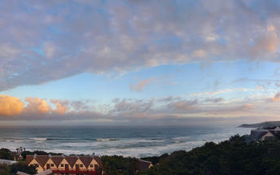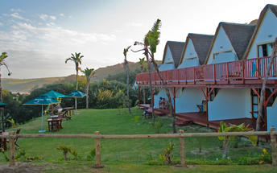

The Wild Coast
The Wild Coast extends for over 200 kilometres along one of South Africa’s most pristine, wild and beautiful sections of shoreline, taking in remote beaches, undulating emerald hills and isolated coves along the way. Those who love peace, quiet and the Great Outdoors would be hard pressed to find a better holiday destination than this scenic wilderness, while it also provides plenty of activities to keep the active and adventurous amused, including fishing, diving, swimming and hiking.

Mthatha
The most important urban centre in the Transkei, Umtata is a bustling city set on the Mtata River, named for the sneezewood (umtati) trees that grow along its banks. Once the capital of the Transkei homeland, Umtata now forms part of the Eastern Cape, but is still the economic and commercial hub of the region. Attractions include the Umtata Dam, with its picnic sites and water sports opportunities, and the Nelson Mandela Museum, which documents the life and times of this phenomenal man – South Africa’s most famous hero and freedom fighter – who grew up in a nearby village.

Eastern Cape History
The Eastern Cape has a rich history as it was here that black Africa in the form of the Xhosas, met with Afrikaners & English colonists met for the first time. From the late 1700s the Xhosa and the eastward moving Afrikaner Trek Boers clashed over cattle and land. This volatile situation was made worse by the arrival of the British 1820 Settlers the end result being 9 Frontier Wars. A portend of things to come as the colonists moved further north.

Included
Dinner, Bed and Breakfast

Day 11: Garden Court King's Beach, Port Elizabeth (Tue, 1 August)

Day Itinerary
We awake to the sounds of the crashing waves and have the morning at leisure to unwind with beach sand between our toes. The beach stretches on uninterrupted for many kilometres and the thick indigenous beach forest is a haven for an amazing variety of birdlife. We set off heading south to Port Elizabeth.
Accommodation: Garden Court Kings Beach

Port Elizabeth
Port Elizabeth or PE is known as the Friendly City and the Windy City and hopefully if you stay here you will get a chance to experience the former and not the latter. Port Elizabeth was established to accommodate British settlers who were bought out on a government sponsored programme to provide a buffer between the warring Cape Dutch and the Xhosa. The little port grew from there and today it is the gateway to the Garden Route, as well as the Eastern Cape’s game reserves and beaches.

Overnight: Garden Court King's Beach
Garden Court offers guests affordable hotel accommodation throughout South Africa. Accommodation is functional and uncluttered and ideal for busy travellers seeking a stay that effortlessly combines value with prestige.
Easy relaxation, well-appointed hotel rooms, and savvy service are hallmarks of the Garden Court experience, with a host of amenities that cater to every need. Garden Court hotel rooms include amenities like air-conditioning, complimentary WiFi, electronic safes, in-room tea and coffee facilities and room service.
Garden Court hotels place an emphasis on business friendly amenities, including self-service workstations and conference facilities for those who may need them. Hotel restaurants offer a selection of breakfasts, lunches and dinners ensuring stress free efficiency whether you are staying for business or leisure.
Geared to the needs of people going places, our 3 star hotels reflect the professionalism, attentiveness and service excellence that is a core value of the Tsogo Sun group. Affordable, practical and comfortable, Garden Court hotels are the preferred accommodation for the discerning business traveller.
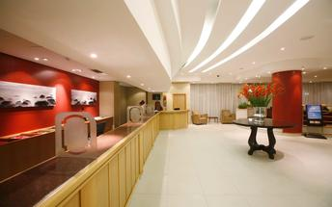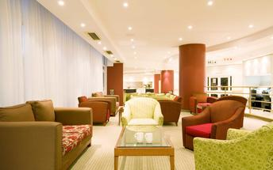

Included
Bed & Breakfast

Day 12: Knysna Hollow Country Estate, Knysna (Wed, 2 August)

Day Itinerary
Today our journey continues towards the Cape. Visit the Tsitsikamma Forest, which provides scenic walking opportunities. A short walk to the Storms River Mouth offers some magnificent views of the gorge and river below. Arrive in Knysna late afternoon for check in at our hotel.
Accommodation: Knysna Hollow Country Estate

Knysna
Nestled between the imposing Outeniqua Mountains and the Indian Ocean and surrounded by world-renowned forests, Knysna offers a wealth of activities for visitors. The beautiful lagoon and more than eight beaches provide opportunities to swim, surf, canoe, yacht, jet-ski, boat, fish, walk on soft sand and take ferry rides. Various markets offer organic goods, delicious food, indigenous plants and a social atmosphere. Mountains, valleys, lakes, forests and streams are ready to be explored. The region isn’t known as the “Garden of Eden” for nothing! A birding route is available for avid bird watchers. World class golf courses are at your doorstep. And of course the area is famous for the Knysna Heads and delicious oysters.

Overnight: Knysna Hollow Country Estate View iBrochure
Beautifully set on a secluded old country estate near Knysna's famous lagoon, Knysna Hollow is focused around a gracious old manor house surrounded by timeless oak and pecan trees. Built in a bygone era, the manor house is finished with pressed ceilings, yellowwood floors and exquisite indigenous furniture. Accommodation consists of 15 Superior Garden Chalets and 64 Garden Rooms, tastefully decorated in a fresh, Knysna forest feel. Visitors can enjoy a superb a la carte restaurant, cosy pub with local Mitchell's brew and a warm welcome with friendly service.
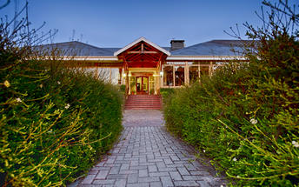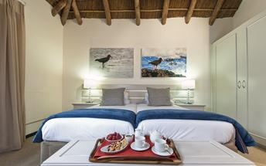

Tsitsikamma National Park
Much of the indigenous forest in this eastern part of the Garden Route falls within the Tsitsikamma National Park. The park is not only a breathtaking haven for indigenous flora and fauna but also for marine life. A marine conservation belt forms part of the park, stretching five and a half kilometres out into the ocean.

Storms River Mouth
The mouth of the Storms River is surrounded by national parks and accommodation, and offers plenty of fun activities. This is where the Otter Trail and Dolphin Trail start as well as numerous smaller hikes. Other activities include crossing the mouth via a suspension bridge, dining at the restaurant overlooking this beautiful site, and swimming and snorkelling in the sea.

Knysna Waterfront
The Waterfront is a central point of activity in Knysna. From here one can board a sunset cruise or ferry ride around the lagoon, do some shopping, enjoy a meal in one of the many restaurants and find accommodation for your stay in Knysna.

Optional Tour NOT included: Featherbed John Benn
The Featherbed Eco tour offers our guests an UNFORGETTABLE, NATURAL and REAL experience!! This pristine piece of paradise situated on the Western Head of Knysna is a privately-owned, registered Nature Reserve and a South African Heritage Site. In order to protect the splendour of the natural beauty, access to the reserve is controlled. Visits are only permitted in the company of the reserve's specialist guides. The nature reserve offers a Knysna adventure activity not to be missed. The eco tour begins with a cruise across the knysna estuary. On arrival at the nature reserve guests will enjoy a 4x4 trailer ride to the top of the Western Head. Here the optional 2.2 kilometre downhill guided walk will begin, passing through Milkwood forests onto the steep sandstone cliffs, into ancient Khoi-San sea caves and along a scenic coastal path fringed with aromatic fynbos. Your guide will inform you on the fauna, flora and bird life in the reserve. On the coastal walk back, you can often spot the resident Black African Oyster Catcher, one of the rarest coastal birds in South Africa. The Food Forest Restaurant is situated on the edge of the Lagoon under a canopy of Milkwood trees where we serve the most sumptuous buffet lunch fit for a king.

Included
Dinner, Bed and Breakfast

Day 13: Garden Court Mossel Bay, Mossel Bay (Thu, 3 August)

Day Itinerary
After breakfast, we travel inland over the spectacular Outeniqua Pass to Oudtshoorn, known as the ‘feather capital of the world’ because of its ostrich industry. We visit a working ostrich farm and then explore the famous Cango Caves. Walk (the more adventurous may crawl!) around the famous Cango Caves with their magnificent dripstone formations of stalactites and stalagmites. Travelling back to the Eastern seaboard, we arrive in Mossel Bay in the afternoon for a visit to the famous Post Office Tree, the Bartholomeus Diaz museum and shell museum.
Accommodation: Garden Court Mossel Bay or similar

Mossel Bay
Mossel Bay has rapidly grown from its days as a little fishing village and holiday resort. The big bay has long sandy beaches and the old town has plenty of historic and recreational attractions – not least of which is the Mossel Bay Golf Course. The course boasts a view of the sea from every tee and the chance to whale watch as you line up your next shot.

Overnight: Garden Court Mossel Bay
The historic town of Mossel Bay was crowned Town of the Year 2007/2008, and offers a number of local attractions for visitors to enjoy. These include beautiful beaches, a waterfront area with harbour, historical landmarks such as the Post Office Tree, and many coastal highlights that lie within the greater Garden Route too.
With just 42 en-suite rooms, accommodation is intimate and tastefully furnished. Furnishings are stylish with a classic yet modern design, while a host of comforts are included in each room to ensure a peaceful stay. These include tea and coffee making facilities, air-conditioning, television with DSTV, electronic safe, complimentary Wi Fi, writing desk, direct-dial telephones, 18-hour room service and other touches to put you at ease.
You will also be able to take advantage of our many services and facilities, including the Wellness Spa that provides plenty of pampering treatments. Dining is enjoyed at The Blue Hibiscus Restaurant, which is open for daily buffet breakfasts and all-day drinks from the bar; lunch and dinner is served at Red Cherry Restaurant (A la Carte) or The Admirals Restaurant (Buffet) while light snacks and drinks are offered at Bravo Lounge. Conferencing is also available for business guests.
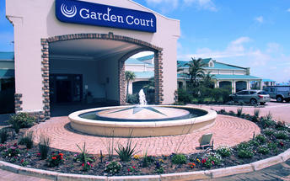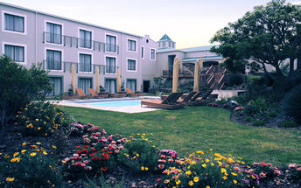

Outeniqua Pass
The road between George and Outshoorn has been upgraded four times and the Outeniqua Pass is the most modern and popular version. One of the world’s grandest road passes, the views are incredible.

Cango Caves
The spectacular Cango Caves are a subterranean wonderland of magnificent stalactite and stalagmite rock formations that attracts thousands of visitors annually. They extend more than two kilometres into the Swartberg Mountains and visitors can take guided tours that wind through narrow passageways and steep stairways linking the massive caverns.

Safari Ostrich Showfarm
Safari Ostrich Show Farm is an operating farm where visitors will see large flocks of ostriches at different stages of development in the surrounding fields. Visitors are assured of personal attention and upon their arrival are greeted by one of our multi-lingual guides who will, during the course of the tour explain every aspect of ostrich farming, from breeding to rearing. The tour starts in the breeding camp, with a nest of ostrich eggs, where the first stage of the ostrich life cycle is explained. Visitors will get the opportunity to test the strength of the eggs by standing on them - a great photo opportunity. During the breeding season visitors get to see ostrich eggs hatching in the incubator rooms. Visitors get to sit on an ostrich and those who are brave enough can even try their hand at riding one. Every tour ends with an "Ostrich Derby" where local jockeys display their riding skills. A highly entertaining and educational tour is guaranteed.

Dolphin Point
Dolphin Point Look Out in Wilderness is one of the most popular view sites along this eastern section of the Garden Route. Receiving its name from the number of dolphins that are spotted from this vantage point at a regular basis, it offers a fantastic panoramic view of the ocean. Whales are also spotted at Dolphin Point Look Out in winter during breeding season.

Bartolomeu Dias (Bartholomew Diaz) Museum
The Dias Museum Complex is one of the highlights of Mossel Bay, commemorating the spot where the Portuguese explorer Bartolomeu Dias first set foot on South African soil and incorporating several museums, monuments and historical sites. Visitors can see the Post Office Tree, a now 500-year-old milkwood tree that served as South Africa’s first post office, the Shell Museum and Aquarium, showcasing hundreds of beautiful sea shells as well as living marine creatures, the Granary Museum, with its displays documenting old wagon trails and indigenous flora, the Maritime Museum, with its exhibits of nautical artefacts and a life-size replica of the caravel on which Dias arrived.

Mossel Bay
Mossel Bay has rapidly grown from its days as a little fishing village and holiday resort. The big bay has long sandy beaches and the old town has plenty of historic and recreational attractions – not least of which is the Mossel Bay Golf Course. The course boasts a view of the sea from every tee and the chance to whale watch as you line up your next shot.

Optional Tour NOT included: Cango Wildlife Ranch
The Cango Wildlife Ranch promotes awareness and conservation of endangered species, while encouraging supervised interaction – making this a wonderful destination for children of all ages. Housing the oldest and largest cheetah contact centre worldwide, visitors can view these powerful, speedy cats in a natural bushveld environment from elevated walkways. From predators of the land to predators of the water, visitors can then move on to the crocodile and alligator enclosures to study more of the world’s most dangerous beasts.

Included
Bed & Breakfast

Day 14: SunSquare Cape Town, Cape Town (Fri, 4 August)

Day Itinerary
After breakfast we head for Cape Town via the towns of Swellendam, Robertson and Worcester. After traveling through the Huguenot Tunnel, iconic Table Mountain greets us as we arrive in Cape Town in the afternoon.
Accommodation: Sun Square Hotel – Cape Town or similar

Cape Town
Resting at the confluence of the Indian and Atlantic Ocean, sandwiched between the slopes of the iconic Table Mountain and the glistening sapphire waters of Table Bay, the exceptionally scenic city of Cape Town is in a class of its own. Some cities boast rich culture, vibrant nightlife, a cosmopolitan atmosphere and extraordinary architecture, while others boast breathtaking landscapes and extraordinary natural wonders. Cape Town, is lucky enough to be blessed with all of these attractions and so much more. With its bustling harbour, world-class beaches, top-notch vineyards, and its mountainous surroundings brimming with diverse flora and fauna, Cape Town consistently captivates the hearts of all who visit.

Overnight: SunSquare Cape Town View iBrochure
For leisure travellers, it is beautifully positioned at the base of Table Mountain – one of the new ‘Seven Wonders of Nature’ and is close to Long Street, with its vast selection of chic restaurants and boutique shops, offering an array of daytime and night time activities. The hotel is also located within close proximity to main attractions in the area such as the V&A Waterfront, South African National Museum, VOC Company Gardens, Table Mountain Cable Stations and the gorgeous beaches of Camps Bay and Bloubergstrand.
The hotel bedrooms are refreshingly modern and offer comfort and style, featuring stylish furnishings, warm lighting, contemporary flat-screen televisions, ultra-modern writing desks, electronic safes, as well as in-room fridges and super-cool new air conditioning. The en suite bathrooms also sport a new look with beautiful chrome and ceramic tile finishes.
The hotel has 136 beautifully-appointed rooms that have been refurbished to deliver simple comfort and contemporary style. Rooms all have great views of Table Mountain or the vibrant city centre and come with en suite shower-bath combination or a shower only as well as a telephone, DSTV with a wide range of channels and individually-controlled air conditioning units. Other features in the rooms include ultra-modern writing desks, an in-room bar fridge and an electronic safe
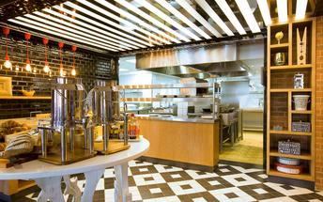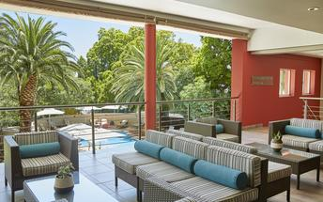

Included
Bed & Breakfast

Day 15: SunSquare Cape Town, Cape Town (Sat, 5 August)

Day Itinerary
Enjoy a day at leisure in the ‘Mother City’ where a visit to the V&A Waterfront is recommended. Enjoy quality time exploring this iconic beautiful city with its many world acclaimed attractions.
Accommodation: Sun Square Hotel – Cape Town or similar

Optional Tour NOT included: Cape Town City Tour Half Day
On a clear day from the summit of Table Mountain you get spectacular views of the City, its Waterfront, Camps Bay, the majestic Hottentots Holland Mountains to the East and the mountains of the Cape Peninsula all the way down to Cape Point to the south.
The Table Mountain cableway, a must for all visitors to the Cape, boasts revolving floors, giving passengers a 360 degree view. After descending the mountain, you will depart on a tour of the “Mother City” taking in Signal Hill – where the Noon Day Gun is fired at midday, every day except Sunday – through the colourful Bo-Kaap or Cape Malay Quarter, past the Grand Parade, City Hall and the Castle of Good Hope and South African Cultural History Museum.

Optional Tour NOT included: Table Mountain Cableway
A trip up Table Mountain is quite rightly one of the first things a tourist wants to do when arriving in Cape Town. Once on the top, a 1000m above the city below, you are rewarded with spectacular 360 views. Take your time and enjoy this unique environment, go for a walk or have a bit to eat at the restaurant with arguably one of the best views possible.

Optional Tour NOT included: Robben Island Ferry
This is where the ferry for Robben Island leaves from. The ticket office also has a little museum and a curio shop.

Optional Tour NOT included: Cape Point Tour Full Day
Highlights of a trip down to Cape Point include; one of the world’s most spectacular drives, Hout Bay, Chapman’s Peak, Noordhoek Beach, the Cape Point Nature Reserve, two lighthouses on the tip of Africa, Boulders Penguin Colony, Simonstown, Kalk Bay and the Kirstenbosch Botanical Gardens.

Optional Tour NOT included: Cape Winelands Day Tour
From Cape Town make your way out into the picturesque winelands visiting South Africa’s most famous wine regions – Paarl, Franschoek and Stellenbosch. Aside from the excellent wines the area is renowned for its food and is steeped in history such as the Taal monument, various museums and the contribution of the French Huguenots. There are also many attractions you wouldn’t expect to find on a wine route, from butterflies to cheetahs and pretty much everything in between.

Included
Bed & Breakfast

Day 16: Overnight Travel (Sun, 6 August)

Day Itinerary
This morning after breakfast, check out of the hotel by 11h00. The remainder of the day will be at leisure until your transfer to Cape Town International airport for your flight to Johannesburg and your overnight flight to Sydney via Perth.

Day 17: Departure (Mon, 7 August)

Day Itinerary
On arrival in Perth exit customs then check in for your flight to Sydney.

